A Two-line Title, the Space Below the Name

O. Jackson1(🖂), K.K. Tan2 and T.R. Padmanabhan3

1Affiliation centre, department, university/company. Numbering if more than one affiliation

email

2Affiliation centre, department, university/company

email

3Affiliation centre, department, university/company

email

**Abstract:** Begin your chapter with an **abstract** that summarizes the content of the chapter in 150 to 250 words.

1 Heading 1

This is the first body paragraph with no-indent. This is the first body paragraph with no-indent. This is the first body paragraph with no-indent..

This is a body paragraph, which is indented as are paragraphs following the first one.

When you use an abbreviation in the text, please cite the full term the first time it is used, immediately followed by the abbreviation in brackets. Please use the abbreviation only thereafter except in section titles where the full term should be used, e.g., population-based incremental learning (PBIL). Note that the full term does not have upper-case initials unless it contains proper nouns etc*.*

 (1)

 (2)

 (3)

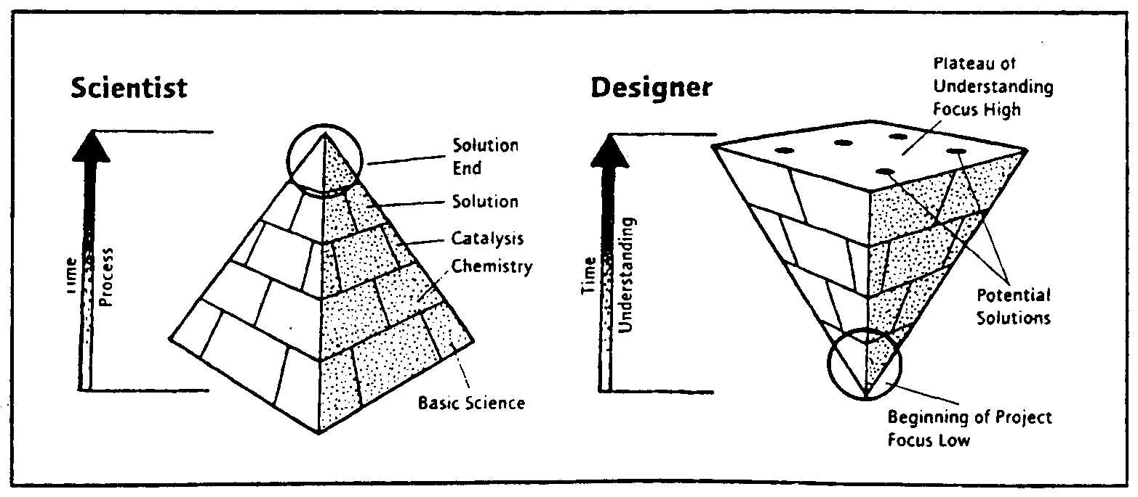Author acknowledgement in the text (Author 2012), two authors (Author and Author 2012), more than two (Author et al. 2012). This is a body paragraph, which is indented as are paragraphs following the first one.

**Fig 1.** A single line of text is centred beneath the figure

This is a body paragraph, which is indented as are paragraphs following the first one. This is a body paragraph, which is indented as are paragraphs following the first one. This is a body paragraph, which is indented as are paragraphs following the first one.

This is a body paragraph, which is indented as are paragraphs following the first one.

**Fig. 2.** Note that although this figure legend takes more than one line of text and is therefore justified, it does not end in a full stop because it only contains one sentence

This is a body paragraph, which is indented as are paragraphs following the first one or an image/table.

2 Heading 1 style Note that this Heading Is Exactly According to the Style Format as It Follows a Body Paragraph, not Another Heading

This is the first body paragraph with no-indent. This is the first body paragraph with no-indent. This is the first body paragraph with no-indent..

This is a body paragraph, which is indented as are paragraphs following the first one or an image/table.

This is a body paragraph, which is indented as are paragraphs following the first one or an image/table

**Table 1.** A single-line table legend is centred above its table

|  |  |  |
| --- | --- | --- |
| Please Use Whichever | of these Formats | Suits The Table |
| But try to be as | Consistent as | Possible |
| Variations in | The spacing above | And below may |
| Be required if a single | Cell contains more than | One paragraph |

This is a body paragraph, which is indented as are paragraphs following the first one or an image/table.

 (4)

Note that, if an equation appears in the middle of the paragraph, the block of text following it is best formatted with the body no-indent para.

**Table 2.** Note that the bolding placed on the table and figure numbers at the beginning of each legend has to be applied manually and is not part of the paragraph style. Also, note that because this legend contains more than one full sentence, it ends with a fullstop - had it contained only one sentence, there would have been no full stop.

|  |  |  |
| --- | --- | --- |
| Please Use Whichever | of these Formats | Suits the Table |
| But try to be as | Consistent as | Possible |
| Variations in | The spacing above | And below may |
| Be required if a single | Cell contains more than | One paragraph |

This is a body paragraph, which is indented as are paragraphs following the first one or an image/table.

2.1 Heading 2 style: Although the Headings Get Smaller, Capitalisation Remains the Same

This is the first body paragraph with no-indent. This is the first body paragraph with no-indent. This is the first body paragraph with no-indent..

This is a body paragraph, which is indented as are paragraphs following the first one or an image/table

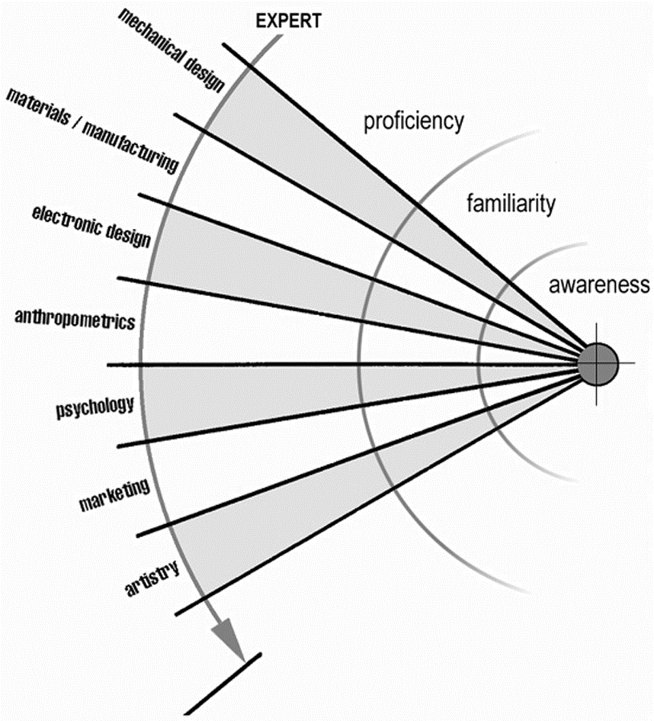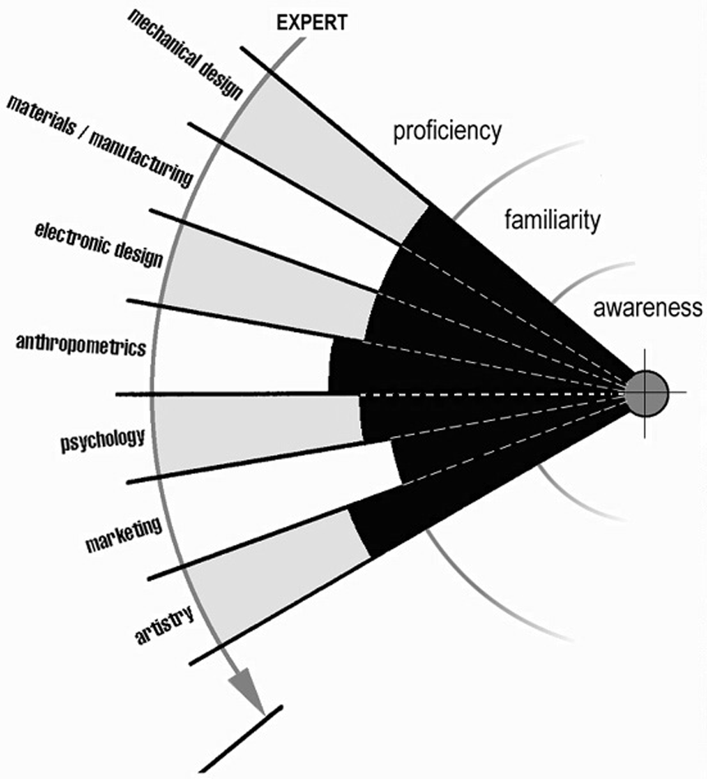This is a body paragraph, which is indented as are paragraphs following the first one or an image/table.

a b

**Fig 3.** Adaptation of the ‘Cone of Industrial Design’ (Bates and Pledgley 1998). Illustration of the skills of: a. the design engineer; b. the industrial engineer. Note that this legend also ends in a full stop because it contains more than one full sentence.

When citing someone else's work, please use the "name and date" system (Jeffries et al*.* 1988). If you wish to insert a quotation from someone else into the text, it should be formatted as follows:

‘We still currently think of the camera as a product dedicated to the task of simply capturing images, but it is not just a camera any more. It’s a camera, an album and a way of editing and choosing. Somehow the design expression has to support all these things. For Kodak, the challenge is to create an interactive experience that supports the brand and the feeling of the right “Kodak moment”.’

(RSA Journal 1999)

The subject that follows, that of the bulleted list is a bit of a minefield because of MS Word's crazy automatic formatting tendencies.

2.2 On the Subject of Lists

I would urge you to avoid all forms of automatic formatting like the plague - in particular, number lists and headings manually, do not allow MS Word to try to do it for you. Note that the introduction to a list usually begins with a colon as follows:

1. note that entries in a list begin with a lower-case initial;
2. and end with a semicolon;
3. except the last one which ends in a full stop.

All the other formatting problems are one-offs and will have to be dealt with on a case-by-case basis - please ask the Editor and if he doesn’t know, he'll ask me. The last thing to concern ourselves with is Section 1.2, which contains references.

References without heading number (found in Styling>manual styling>tail>reference list heading

Adelson B, Soloway A (1986) A model of software design. International Journal of Intelligent Systems 1:195-213

Ball LJ, Evans JStBT, Dennis I (1994) Cognitive processes in engineering design: A longitudinal study. Ergonomics 37: 1753-1786

Ball LJ, Lambell NJ, Ormerod TC, Slavin S, Mariani JA (2000) Representing design rationale to support innovative design re-use: A minimalist approach. Automation in Construction, in press

Ball LJ, Maskill L, Ormerod TC (1998) Satisficing in engineering design: Causes, consequences and implications for design support. Automation in Construction 7: 213-227

Ball LJ, Ormerod TC (2000) Putting ethnography to work: The case for a cognitive ethnography of design. International Journal of Human-Computer Studies, in press

Cross N (1994) Engineering design methods: Strategies for product design, 2nd edn. Wiley, Chichester

Gero JS (1990) Design prototypes: A knowledge representation schema for design. AI Magazine 11: 26-36

Jeffries R, Turner AA, Polson PG, Atwood ME (1981) The processes involved in designing software. In: Anderson JR (ed.) Cognitive skills and their acquisition. Erlbaum, Hillsdale, NJ, pp 255-283